Response Form

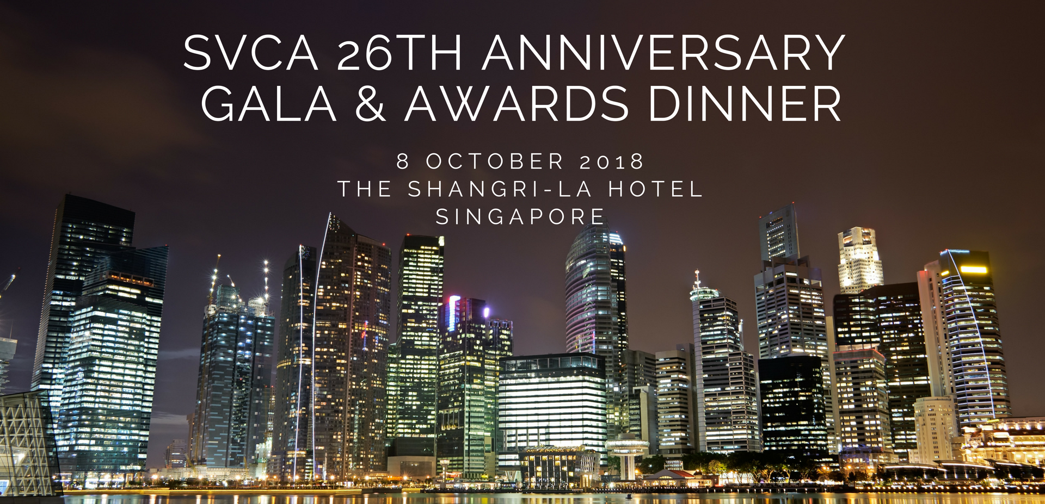

RSVP Deadline: 1 October 2018

☐ Yes, I would like to purchase table(s) at S$5,000 per table of 10 seats.
☐ Yes, I would like to purchase individual seats at S$500 per seat.

I am pleased to enclose my cheque no. for S$
made payable to the “Singapore Venture Capital & Private Equity Association”.

Please mail your cheque together with this Response Form to:

SVCA
14 Robinson Road #07-02A Far East Finance Building Singapore 048545

Company Name:

Address:

Contact person: Tel No.:

Email: Fax No.:

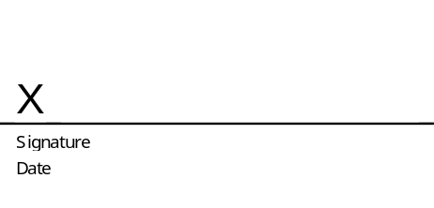
Please note that table placement will be based upon the receipt date of cheque.
Purchase early to ensure prime table location.

